- Build a simple NLP pipeline in Python using NLTK that demonstrates the major steps of Natural Language Processing:

  - Lexical Analysis (Segmentation & Morphological Analysis)
  - Syntactic Analysis (Parsing & Grammar)
  - Semantic Analysis (Meaning Representation)
  - Pragmatic Analysis (Context Understanding)
  - Machine Translation (Simple English-to-other-language translation)

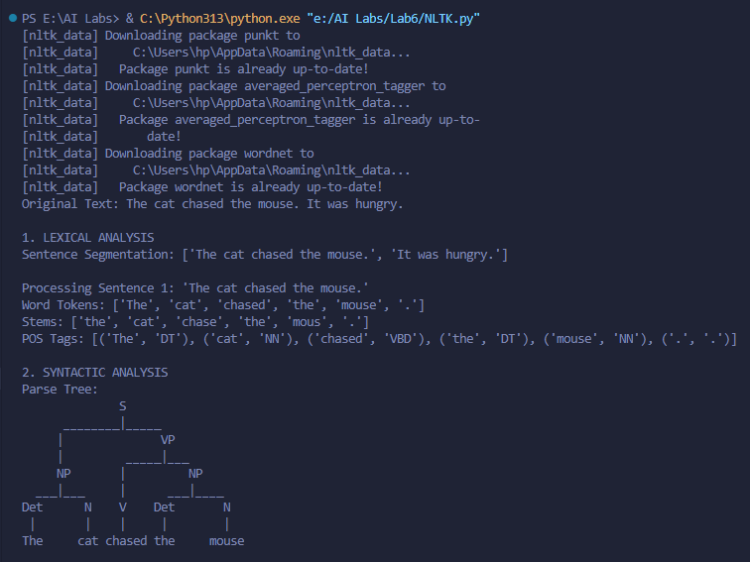

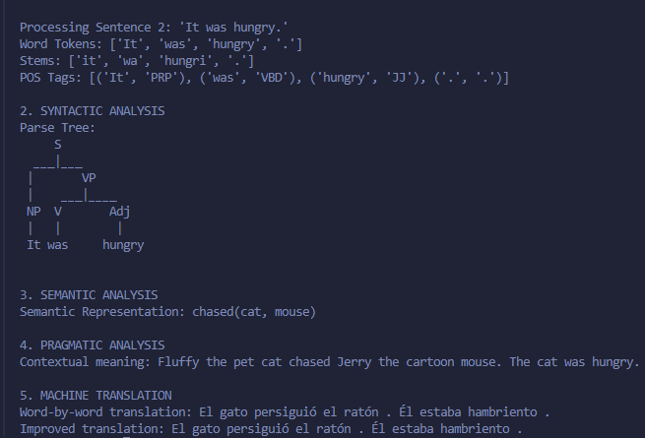

- Build a simple NLP pipeline in Python using spaCy that demonstrates the major steps of Natural Language Processing:
  - Lexical Analysis (Segmentation & Morphological Analysis)
  - Syntactic Analysis (POS tagging & Dependency Parsing)
  - Semantic Analysis (Word similarity, synonyms via WordNet)
  - Pragmatic Analysis (Named Entity Recognition & Context Understanding)
  - Machine Translation (English → another language)

